## **How to Install XCIPTV on Firestick**

**1.** Click the search box.

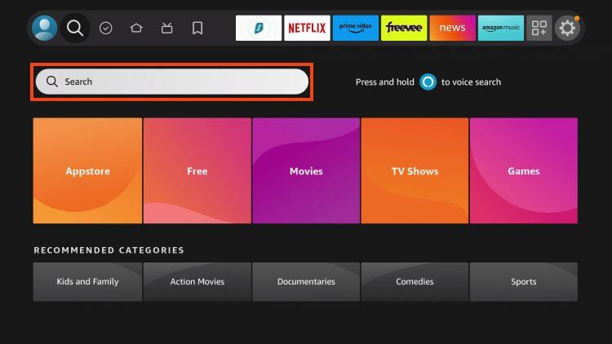

**2.** Type Downloader and choose it.

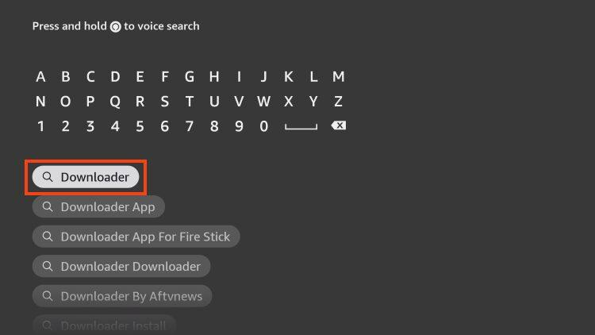

**3.** Click the Downloader app created by AFTVNews.

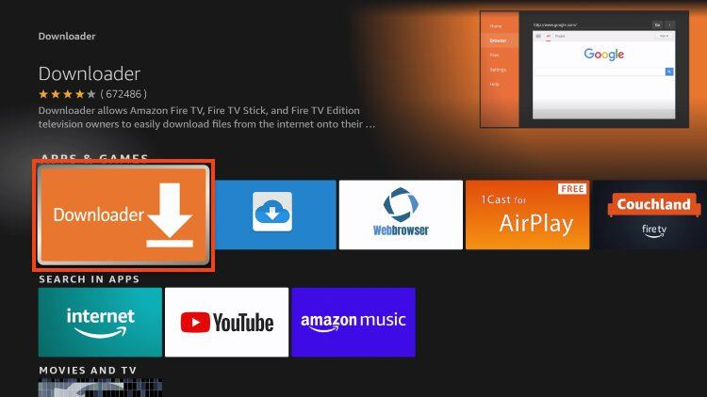

**4.** Choose Get or Download.

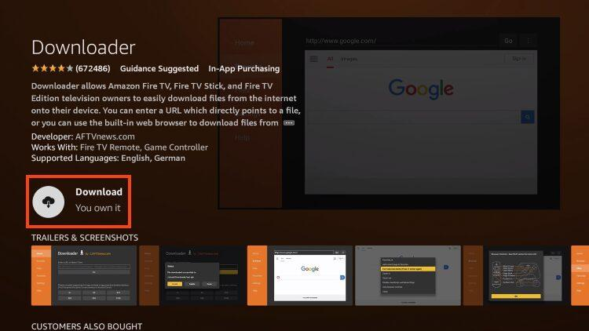

**5.** Installing message will appear.

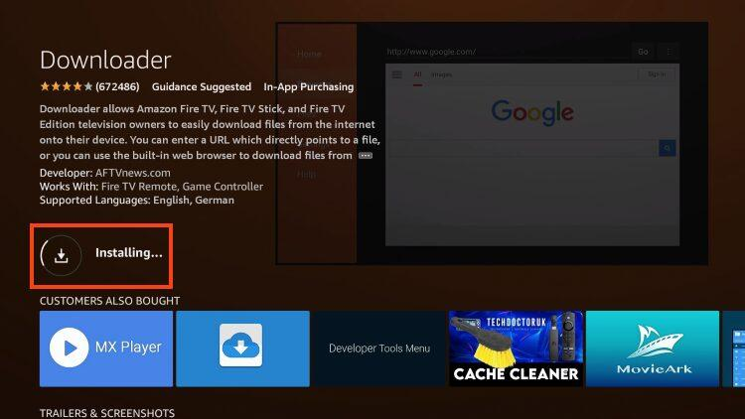

**6.** Once finished, you will see *Downloader Ready to launch!* message.

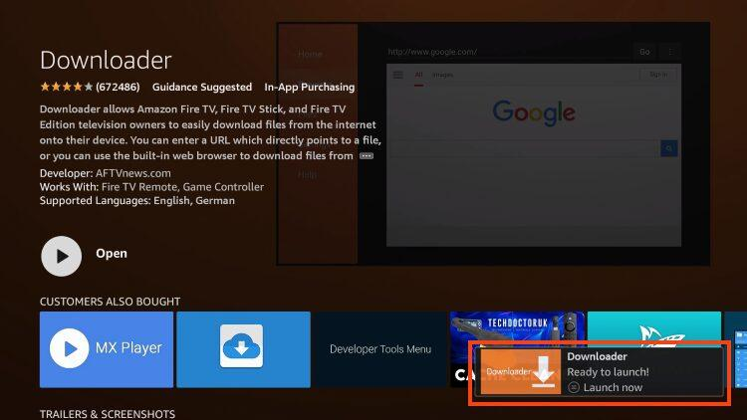

We must now enable Unknown Sources for the Downloader app to “sideload” XCIPTV.

**7.** Go back to Settings and select My Fire TV.

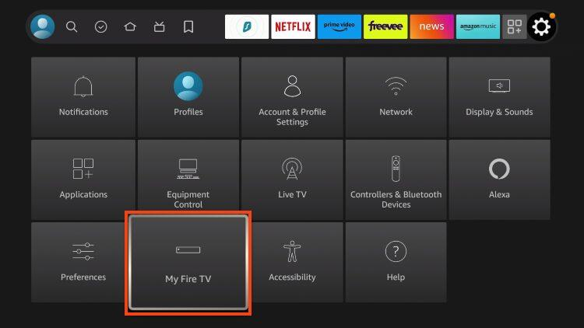

**8.** Select Developer options.

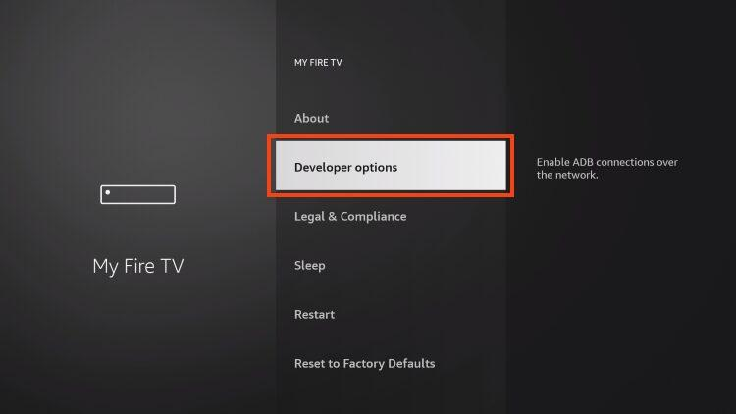

**9.** Choose Install unknown apps.

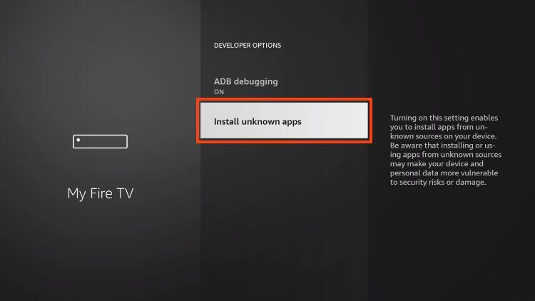

**10.** Click the Downloader app.

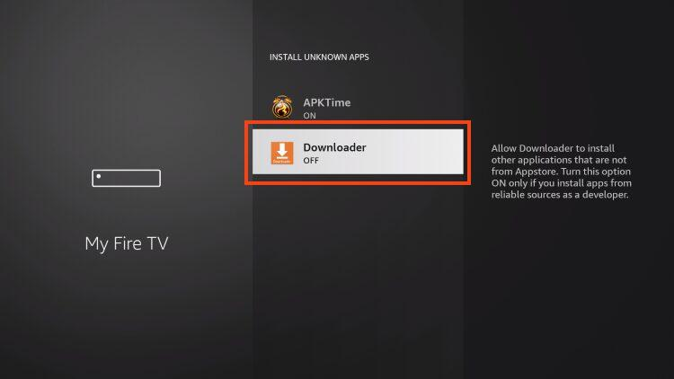

**11.** Make sure this now says “ON”.

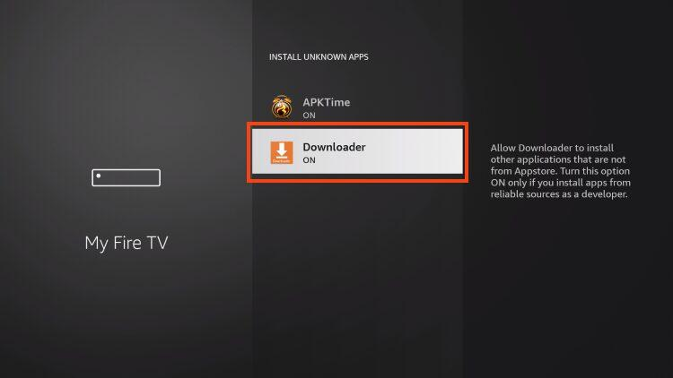

**12.** Open Downloader which we just installed.



**13.** Open the URL bar.

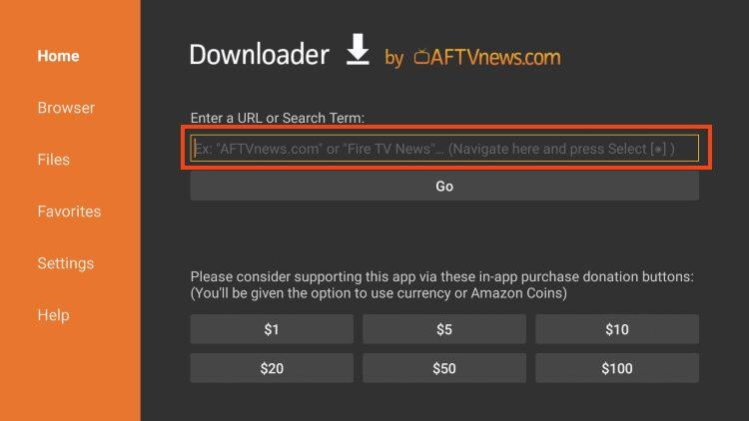

**14.** Type: **sandflaw.com/xc.apk** and click Go.

**16.** Wait a minute or so for the app to download.

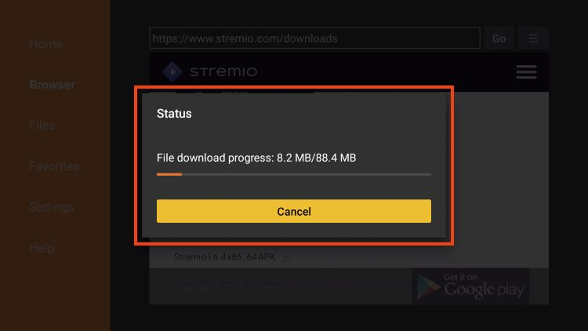

**17.** Click Install.

**21.** Hit the home button on your remotes and then hit the icon that looks like three squares and a plus (my apps and games) and then in there, find the xciptv icon (looks like a blue diamond with a play button in it), highlight it, hit the button on your remote that looks like three dashes and then select “move to front”. Now you are done and xciptv should be on the main screen!

**22**. Open XCIPTV the blue diamond icon on your main screen.

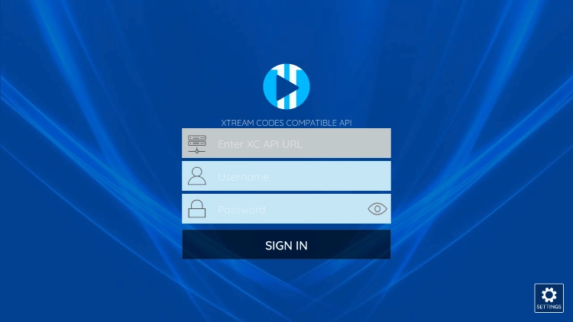

You should see this screen.

For Enter XC API URL enter

<https://us.simpletowne.com>

And hit next

For username enter

NbZqPCHj4s

And hit next

For Password Enter

7JuFGsJQFx

And hit next

Then the Sign In button should be light blue, if so click it and you should log in!

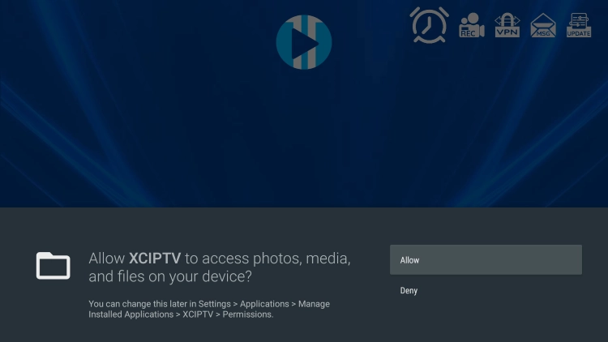

Click allow if this message comes up!

And you’re done! You should see this screen now!

