## **How to Install Stremio on Firestick**

**1.** Click the search box.

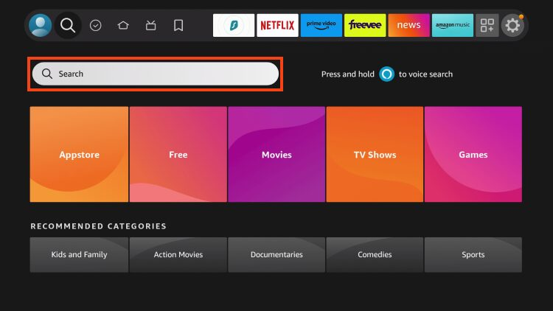**2.** Type Downloader and choose it.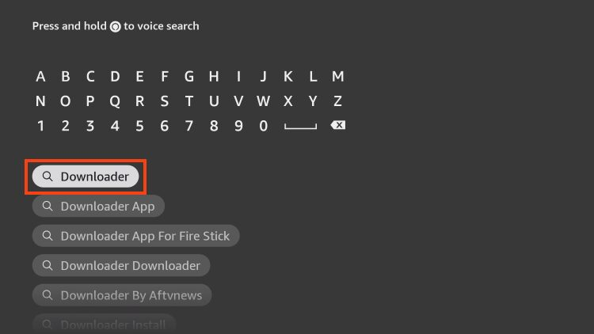

**3.** Click the Downloader app created by AFTVNews.

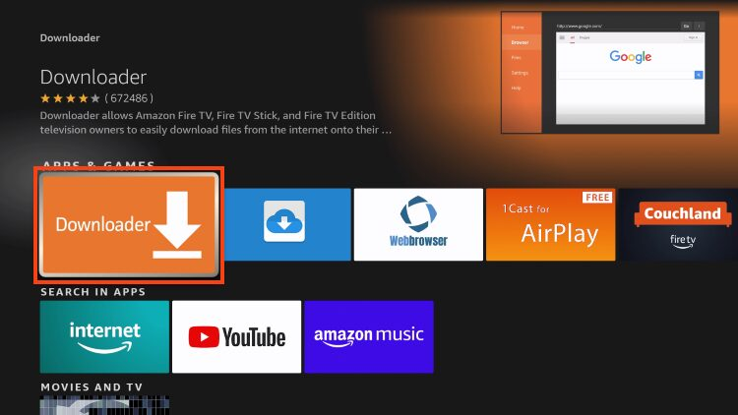

**4.** Choose Get or Download.

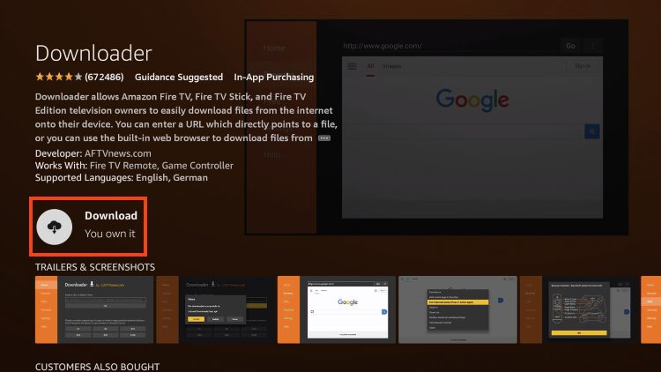

**5.** Installing message will appear.

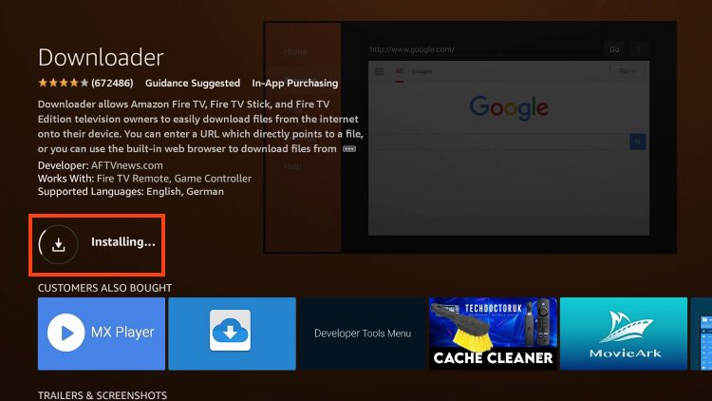

**6.** Once finished, you will see *Downloader Ready to launch!* message.

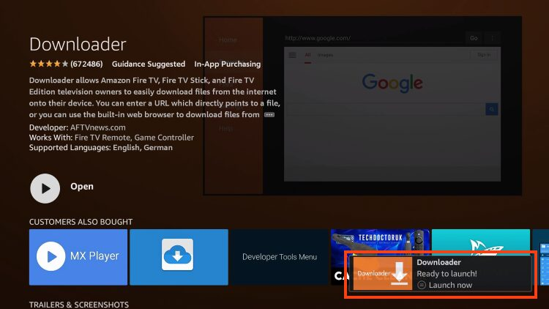

We must now enable Unknown Sources for the Downloader app to “sideload” Stremio.

**7.** Go back to Settings and select My Fire TV.

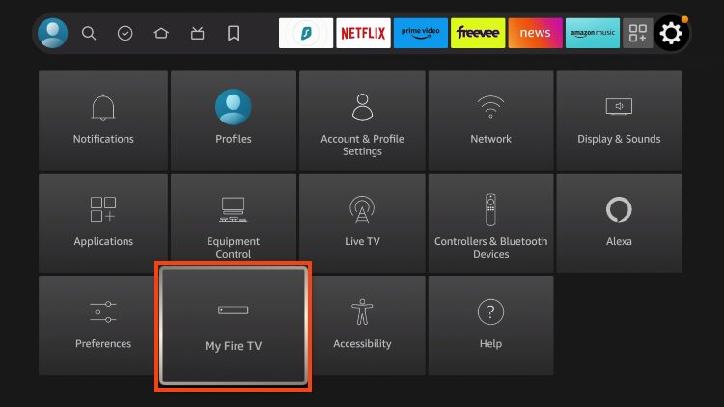

**8.** Select Developer options.

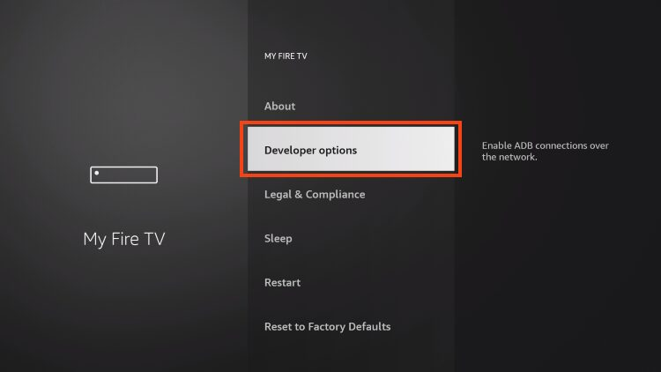

**9.** Choose Install unknown apps.

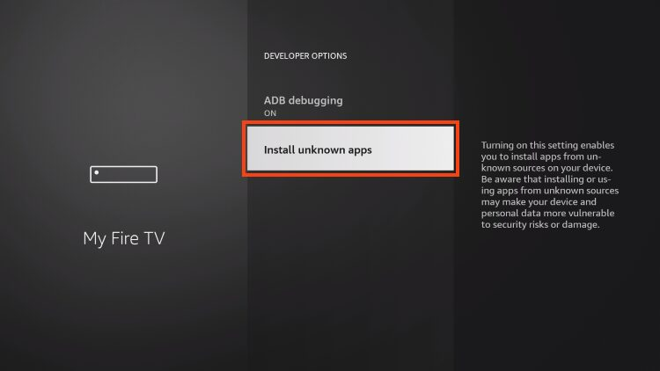

**10.** Click the Downloader app.

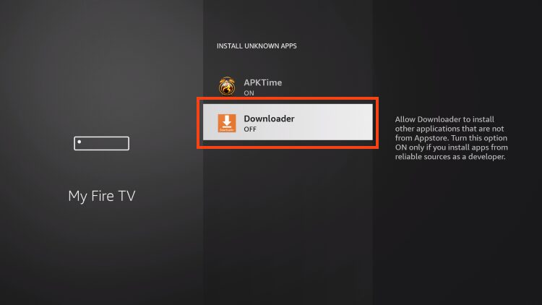

**11.** Make sure this now says “ON”.

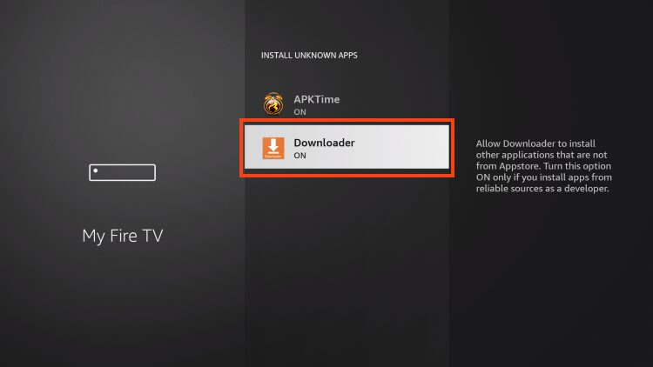

**12.** Open Downloader which we just installed.



**13.** Open the URL bar.

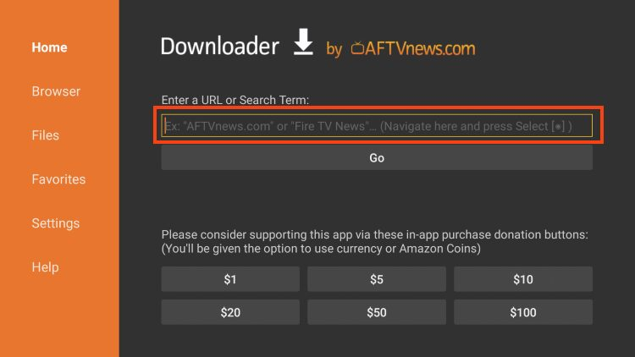

**14.** Type: **stremio.com/downloads** (the official stremio website) and click Go.

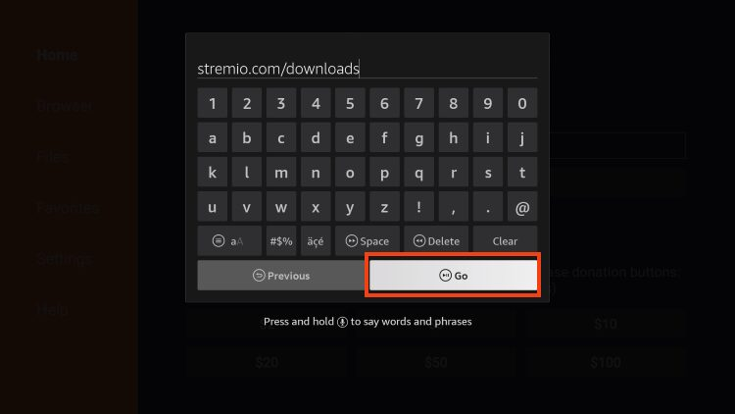

**15.** Scroll down to Stremio for Android TV and select the ARM APK.

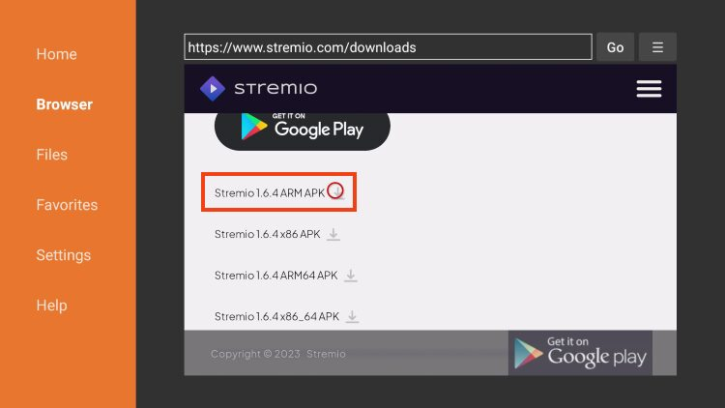

**16.** Wait a minute or so for the app to download.

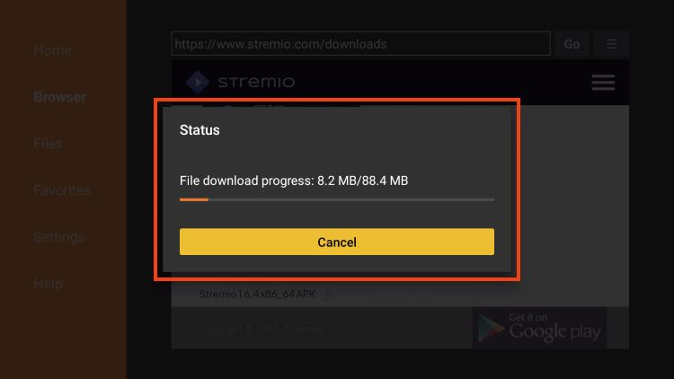

**17.** Click Install.

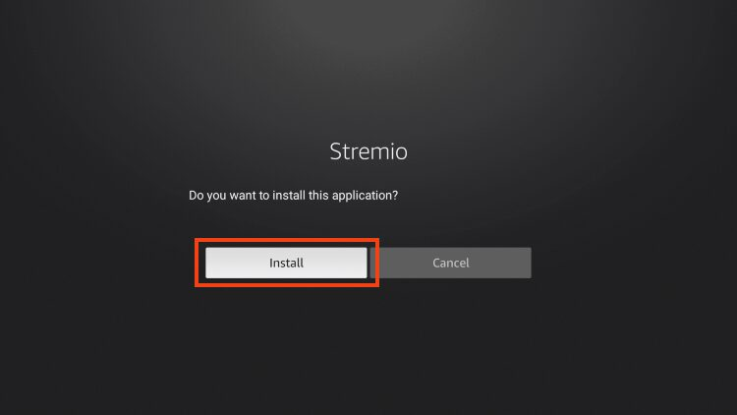

**18.** You will then see the *Stremio Ready to launch!* message. Click Done.

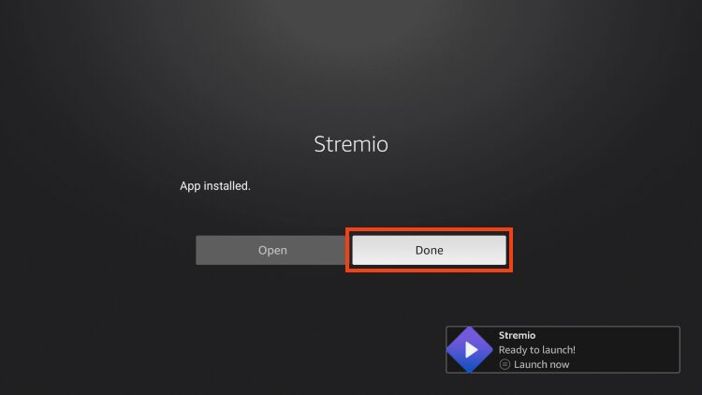

**19.** If you want to remove the installation file, select Delete.

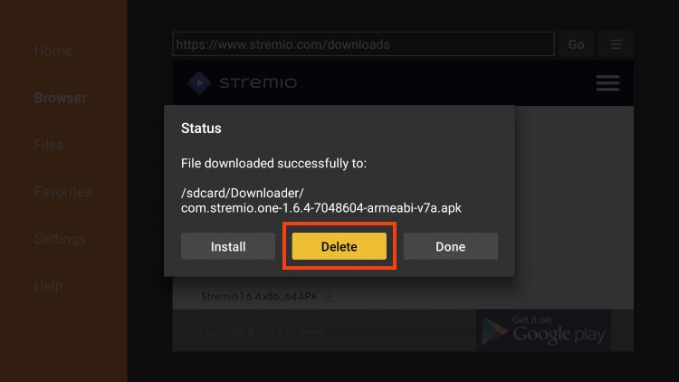

**20.** Click Delete again.

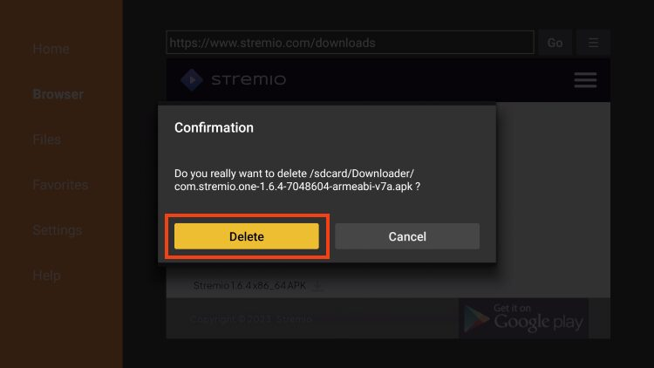

**21.** Hit the home button on your remotes and then hit the icon that looks like three squares and a plus (my apps and games) and then in there, find the stremio icon, highlight it, hit the button on your remote that looks like three dashes and then select “move to front”. Now you are done and stremio should be on the main screen!